BME 105: Winter 2020

Short answer
Question 10
For Locus 3, what are the genotypes for I-1, I-2, II-1.
For simplicity, you can use "a" for α
For simplicity, you can use "b" for β
For example, if the genotype is αα, you can input aa.
There are multiple ways to write out the genotype, so input the genotypes into the text box. Makes sure it is clear which genotype you are indicating for which individual.

Given the read depth at this locus, this indicates that the locus is on the Y chromosome.

I-1: XY^{α}
I-2: XX
II-1: XY^{α}

Extended Problems with Extended Calculations

1. The following is a human pedigree of a family affected with an extremely rare disease.

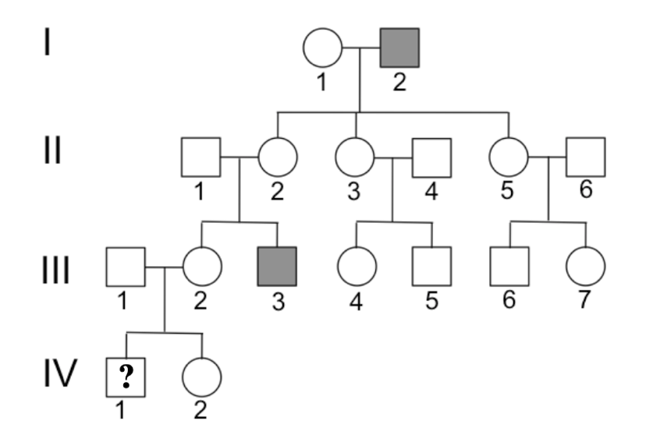

(3 points) a. What is the most likely mode of
inheritance of this disorder?

X-linked recessive

(3 points) b. What are the genotypes of the
following individuals in the pedigree? If there are multiple possible genotypes, please list all possible ones.

i. I-1:

X^{A}X^{A}

ii. II-2:

X^{A}Xª

iii. III-2:

X^{A}X^{A} or X^{A}Xª

(8 points) c. What is the probability that individual IV-1 will be affected (show your calculations!)?

P(IV-1 affected) = P(IV-1 is XªY and III-2 is X^{A}Xª)
= P(IV-1 is XªY given III-2 is X^{A}Xª) * P(III-2 is X^{A}Xª)
= 1/2 * 1/2 = 1/4

(8 points) d. What is the probability that III-7 is a carrier?

P(III-7 is a carrier) = P(III-7 is X^{A}Xª and II-5 is X^{A}Xª)
= P(III-7 is X^{A}Xª given II-5 is X^{A}Xª) * P (II-5 is X^{A}Xª)
= 1/2 * 1 = 1/2

2. You would like to construct a mouse model for the human genetic
condition hypochondroplasia which is caused by a hypermorphic FGFR3 allele in
which a DNA mutation at the 541th codon position changes an N to a T amino
acid.

(3 points) Is a hypermorphic mutation gain-of-function or loss-of-function?

Gain-of-function

(3 points) You consider multiple options to create a mouse model for this condition. Which of the following would possibly be useful for your studies. Indicate all possible answers.

- Transgenic mouse overexpressing a normal mouse protein
- Transgenic mouse expressing normal amounts of a mutant protein
- Transgenic mouse expressing a dominant negative form of a protein
- A knockout mouse
- A conditional knockout mouse
- A knockin mouse in which the normal allele is replaced with a mutant allele that is a least partially functional

1,2,6 are possible answers. #6 is best answer and must be included. Incorrect if 3, 4, or 5 is selected. Partial credit if #1 or #2 are given and not #6.

Below, you will describe your experiment to make a good mouse model for hypochondroplasia using the CRISPR/Cas9 system.

(6 points) You will need to design a crRNA sequence to guide Cas9 cutting in the mouse genome. Below is part of the exon sequence in the FGFR3 gene where the hypermorphic mutation exists. The wild-type sequence is shown and the position of the hypermorphic mutation (A->C) is underlined.

5’-AAACACAAAAACATCATCAACCTGCTGGGCGC-3’

In most cases a crRNA sequence is 20nt, but for simplicity, we will only design a 5nt crRNA.

List all possible crRNA sequences that could be designed to target Cas9 enzyme. Indicate 5’ and 3’ ends and remember that crRNA is an RNA molecule.

5’-CCUGC-3’
5’-CUGCU-3’
5’-CCAGC-3’ (PAM on reverse strand)

2 points for each correct crRNA given. Note that PAM sequence is not included in the crRNA sequence.

(30 points, 6 points each response) After designing your CRISPR sgRNA, you are now ready to create your mouse model. For your mouse experiment please state:

Since you are modeling a hypermorphic allele, the best model is to introduce the same point mutation. You will make a CRISPR knockin mouse.

i) what DNA construct, RNA construct, and/or protein you would introduce
into the mouse cells. You may draw pictures. Indicate any selectable
markers on DNA or RNA that you may introduce.

You need to introduce three components into zygote. (1) The sgRNA described above. The sgRNA can be introduced in an expression vector or as a synthetically made RNA. (2) The DNA template that contains the point mutation that you would like to introduce by homologous recombination (3) The Cas9 protein. This can be injected as a protein or as a DNA construct with the Cas9 coding region downstream of a strong promoter

ii) whether you would put the DNA into a zygote or ES cells

zygote

iii) if introducing DNA, where in the mouse genome does the DNA
integrate

For the sgRNA or Cas9 introduction, depending on the DNA construct used (particularly linear pieces of DNA), the DNA would be incorporated at a random position in the genome.

The DNA template used to introduce the point mutation needs to be mentioned here. The exact mechanism of homologous recombination was not discussed in class, so as long as there is some mention that this DNA template (containing the point mutation) is incorporated into the endogenous location in the genome, then points should be given.

iv) whether creating the mouse should involve the generation of a chimera
or not

I might have misspoken during lecture. I might have mentioned that CRISPR/Cas9 mice, when components are injected in a zygote, generate chimeras, but this is actually unlikely. However, the final result of the CRISPR experiment may result in different mutations on both copies of the chromosome, one copy of the chromosome, or no mutation at all.

If a reasonable answer is given here, full points should be given.

v) which additional breeding steps you would do to make the mouse you
wanted

Most likely you want to generate a heterozygous mouse to best model the disease, but it is fine if there is mention of making a mouse that is homozygous mouse.

After injection, the zygotes are placed in receptive females or the injections were done directly in oviduct of females. When born, these mice are genotyped using PCR and Sanger sequencing or restriction digest. Those that show evidence of genome editing are crossed with wild-type adult mice to create F1 progeny that are heterozygous. You can, again, genotype using PCR followed by Sanger sequencing. If making homozygous mice, these F1s are crossed to generate F2 progeny that are homozygous for the point mutation.

